Streamline2 Execution Notes

**Issue #3: Ran out of memory trying to run on GPU with 27G of RAM**

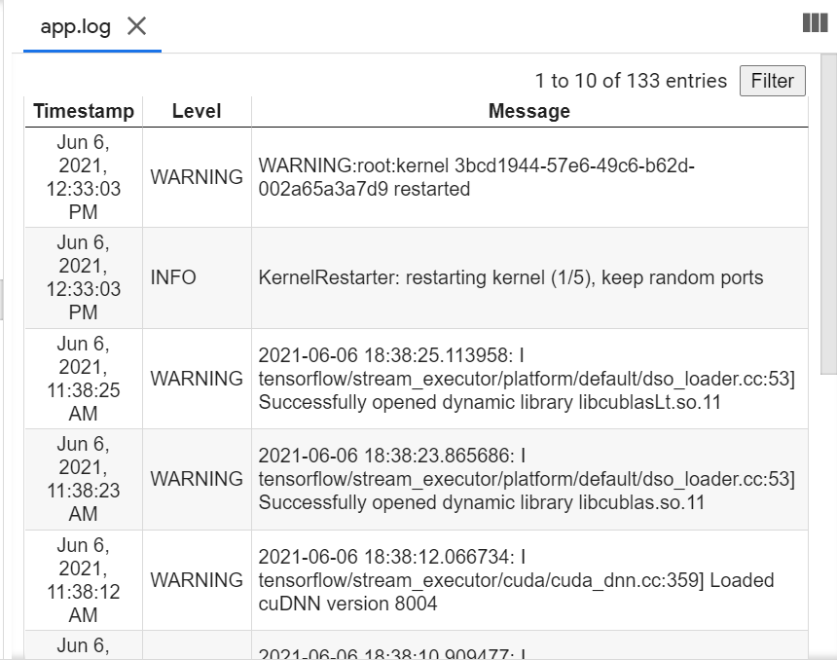

**Issue #2: Trying to run on TPU – tf is able to read this data in but when it goes to train the model this is what I get:**

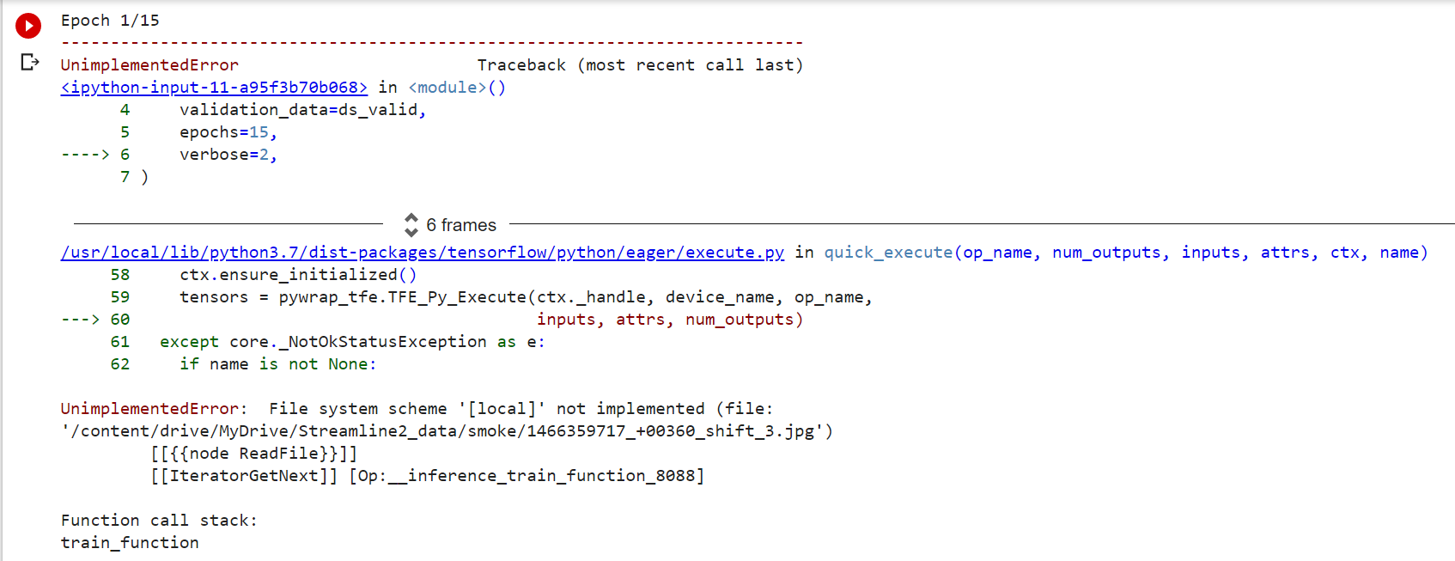

**Issue #1**

From https://stackoverflow.com/questions/48658204/tensorflow-failed-call-to-cuinit-cuda-error-no-device



